**5 easy to understand SQL queries to get you started with PATSTAT**

Below is a list of 5 straightforward SQL queries that can be PASTE/COPIED into the “Query” area of PATSTAT Online. In order to get access to PATSTAT Online, you can request a test account via this link:

<https://data.epo.org/access-control/patstatsubscription.jsp> .

You can experiment as much as you want with these queries by adding extra attributes (fields) in the SELECT clause or changing the conditions specified in the WHERE clause. There is no danger of “breaking” the system; at most a changed query might have wrong syntax and then you will see a red coloured message indicating the error.

**SQL syntax**

The attributes (fields) listed following the SELECT will be in the final output table.

The (joined) tables listed after the FROM clause specify the input tables used to retrieve the attributes listed in the SELECT clause.

The WHERE clause specifies the conditions to be fulfilled by the retrieved records.

If you want to create statistics in PATSTAT Online then the attribute “**appln_id**” has to be listed in the SELECT clause. The green parts in the query, preceded by ‘--‘ indicate comment lines that explain that part of the query. They will not affect the execution of the query.

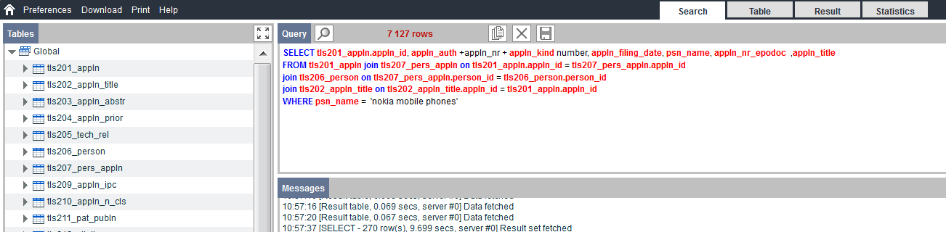

*Query 1: will list all granted EP applications having a year of filing = 2010.*

*The select clause also lists the application identification (appln_id); therefore PATSTAT Online statistics can be created based on this query.*

SELECT appln_id, appln_auth +appln_nr + appln_kind number, appln_filing_date

FROM tls201_appln

WHERE appln_filing_year = 2010 --application filing year = 2010

AND appln_auth ='EP' --EP applications

AND granted = 'Y' --the patent has been granted

*Query 2: will list all EP applications that were filed between 2010 and 2015 (included) which have a CPC classification symbol in the field of wind energy. Applications that have multiple CPC classifications in wind energy will be listed multiple times in the result. Observe the blanks and % wildcard in the CPC classification symbol ! Before the “/” in the CPC symbol, there should always be 8 characters. The select clause lists the application identification, therefore statistics can be created.*

SELECT tls201_appln.appln_id, appln_auth +appln_nr + appln_kind number, appln_filing_date, cpc_class_symbol

FROM tls201_appln JOIN tls224_appln_cpc

ON tls201_appln.appln_id = tls224_appln_cpc.appln_id

WHERE appln_filing_year between 2010 and 2015 --application filing between 2010 and 2015

AND appln_auth ='EP' --EP applications

AND cpc_class_symbol like 'Y02E 10/7%' --CPC classification for wind energy

ORDER BY tls201_appln.appln_id --orders the results per application

*Query 3: will list all applications filed by* 'NOKIA SOLUTIONS AND NETWORKS'. We used the PATSTAT Standardised Name (psn_name) which will give more coherent applicant names if we would have used the “person_name” (name as published on the patent document) instead.

*The select clause lists the application identification, therefore statistics can be created.*

SELECT tls201_appln.appln_id, appln_auth +appln_nr + appln_kind number, appln_filing_date, psn_name, appln_nr_epodoc, appln_title

FROM tls201_appln JOIN tls207_pers_appln ON tls201_appln.appln_id = tls207_pers_appln.appln_id

JOIN tls206_person ON tls207_pers_appln.person_id = tls206_person.person_id

JOIN tls202_appln_title ON tls202_appln_title.appln_id = tls201_appln.appln_id

WHERE psn_name = 'NOKIA SOLUTIONS AND NETWORKS'

-- all application filed by = 'NOKIA SOLUTIONS AND NETWORKS'

ORDER BY appln_filing_date desc -- orders the results on the application filing date

*Query 4: creates a hitlist of EP applications having Chinese applicant.*

*The select clause does not list the application identification (because we counted the number of applications) and therefore NO statistics can be created.*

SELECT psn_name, person_ctry_code,

count(tls201_appln.appln_id) APPLICATIONS_AT_EPO -- Counting applications

FROM tls201_appln join tls207_pers_appln on tls201_appln.appln_id = tls207_pers_appln.appln_id

join tls206_person on tls207_pers_appln.person_id = tls206_person.person_id

WHERE person_ctry_code = 'CN' --Chinese “persons”

and applt_seq_nr > 0 AND invt_seq_nr = 0 --only consider applicants, exclude inventors

and appln_auth = 'EP' --EP applications

GROUP BY psn_name, person_ctry_code -- creates totals per name/country combination

ORDER BY count(tls201_appln.appln_id) desc -- order in descending number of applications

*Query 5: creates a list of granted EP applications filed by Chinese applicants for which a renewal fee was paid in Belgium. The “* AND appln_auth = 'EP' *” condition in the WHERE clause is in principle redundant because the “*event_code = 'PGFP'*” (Post Grant Fee Paid) condition implies that the application is a granted European patent. (EP).*

*The select clause does list the application identification and therefore statistics can be created.*

*OBSERVE ! the fact that a renewal fee is (was) paid does not imply that all these patent are still valid. One could (more or less) conclude that renewal fees paid in 2016 and 2017 would imply that the patent is still valid in Belgium (in 2017 and 2018).*

SELECT distinct psn_name, person_ctry_code, appln_auth +appln_nr + appln_kind number, appln_filing_date, fee_country, fee_payment_date, fee_renewal_year, appln_title, tls201_appln.appln_id

FROM tls201_appln join tls207_pers_appln ON tls201_appln.appln_id = tls207_pers_appln.appln_id

JOIN tls206_person ON tls207_pers_appln.person_id = tls206_person.person_id

JOIN tls231_inpadoc_legal_event on tls201_appln.appln_id = tls231_inpadoc_legal_event.appln_id

JOIN tls202_appln_title on tls201_appln.appln_id = tls202_appln_title.appln_id

WHERE person_ctry_code = 'CN' --Chinese “persons”

AND applt_seq_nr > 0 --only consider applicants

AND appln_auth = 'EP' --EP applications

AND event_code = 'PGFP' -- a Postgrant Fee was paid (implies granted EP)

AND fee_country = 'BE' -- fee paid in Belgium

order by fee_payment_date desc -- order in descending fee payment date

Document compiled by: PATSTAT team EPO Vienna.

Feedback & suggestions can be send to: patstat@epo.org