Epo.org website press release
Please fill out this template. When your press release is approved, you can submit it for publication via the PD Communication Single Point of Contact.

For keywords and Search Engine Optimisation descriptions, please see the intranet page: https://confluence-p.internal.epo.org/display/EPOWeb/SEO+Guidelines+for+editors
- Background information
Press release approved by  Always indicate who has approved the publication of the press release | PD Communication
Author  Please indicate the content owner. This will not be published | Sophie Rasbash/Jeremy Philpott
Publication date | 19 September 2023
Topic  Select one from the following list  AI & digital technologies  Coronavirus  Sustainability  Biotechnology & life sciences  European and international co-operation  EPO  European Inventor Award  Statistics  Sustainable technologies  Unitary Patent & Unified Patent Court | Statistics
Description  Maximum 230 characters  Provide a keyword-rich summary to boost search engine ranking | A new report published by the EPO shows that innovation in additive manufacturing, also known as 3D printing, has surged in the past decade. The study finds that between 2013 and 2020, international patent families in 3D printing technologies grew nearly eight times faster than for all technology fields combined in the same period.
Keywords  To support search | 3D printing, additive, manufacturing, technology, patents, statistics, study, economist, international, trend, report, study
Download  Provide URLs of the “Word” equivalents in Razuna | (N/A)

- Visuals
Visual elements need to be attached in the request form as individual image files (JPEG). Please use the following guidelines (JPG for photos; PNG for graphics):

  - Avoid text on images
  - max file size 2MB
  - ratio 16:9; ideal dimensions: 1920 x 1080 pixels; min. dimensions 900 x 506 pixels

Videos can also be embedded into press releases – please provide the YouTube link.

Please add brief descriptions (alt-text) for each image, describing its appearance or function. Alternative text is read aloud by screen readers used by visually impaired users, displays in place of an image if it fails to load and is indexed by search engines contributing to higher ranking of your content.

More guidance on alt texts is available at: https://confluence-p.internal.epo.org/display/DSM/_A11y+Content+Editors+and+Content+Creators#id-_A11yContentEditorsandContentCreators-ALT-Text&alternativecontentforcompleximages

Images alternative text  Provide one alt-text for each of the provided images | Images are saved here:  - Trends in patenting in 3D printing technologies  - Countries of origin of international patent families in 3D printing technologies  - Top applicants in 3D printing technologies
- Text
Headline | EPO study: Patent filings in 3D printing grew eight times faster than average of all technologies in last decade
Summary line  Maximum 150 characters including spaces | A new report published by the EPO shows that innovation in additive manufacturing, also known as 3D printing, has surged in the past decade.

Press release

EPO study: Patent filings in 3D printing grew eight times faster than average of all technologies in last decade
- New report from European Patent Office (EPO) shows patenting in additive manufacturing (3D printing) increased at an average annual rate of 26.3% between 2013 and 2020
- Over 50 000 international patent families related to 3D printing technologies have been filed around the world since 2001
- Around 12% of these filings came from universities and public research organisations, almost double their typical share for other technologies
- The US takes the top spot, with 40% of all international patent families related to 3D printing between 2001 and 2020; with Europe contributing 33%

Munich, 19 September 2023 – A report published by the European Patent Office (EPO) today shows that innovation in additive manufacturing, also known as 3D printing, has surged in the past decade. The study, Innovation trends in additive manufacturing, finds that between 2013 and 2020, international patent families in 3D printing technologies grew at an average annual rate of 26.3% – nearly eight times faster than for all technology fields combined in the same period (3.3%).
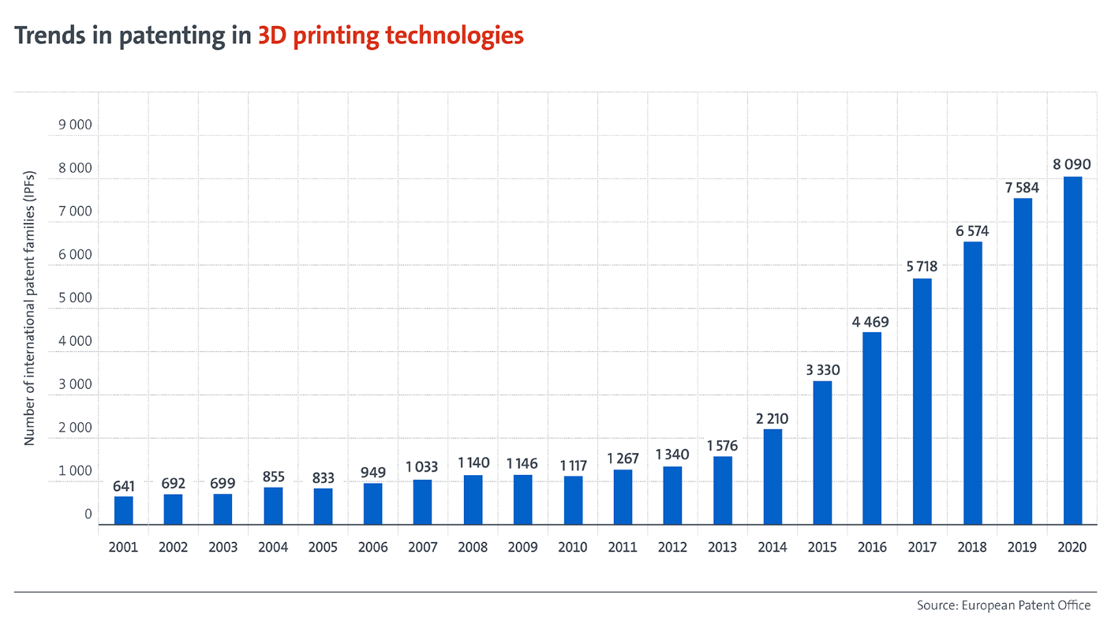

The 3D printing market has also become more diverse. While previously the main players were established engineering companies, there are now also many start-ups and specialised additive manufacturing companies emerging. In total more than 50 000 international patent families (IPFs) for 3D printing technologies have been filed worldwide since 2001. An IPF represents a significant invention for which patent applications have been filed for two or more countries worldwide.

“With this study, we’re taking a global perspective on the 3D printing revolution using international patent data to report on the scope and implications of this technology trend,” says EPO President António Campinos. “Europe secured four of the top ten spots for research institutions in additive manufacturing innovation. This bodes well for the future since technical progress in this field often stems from the cutting-edge research in these institutions.”
US, European, and Japanese companies at the forefront
Europe and the US are leading the global race for 3D printing innovation. The US holds the top spot, with 39.8% of all IPFs related to additive manufacturing between 2001 and 2020. Europe (39 EPO member states) closely follows with a 32.9% share. Together, these regions account for nearly three-quarters of worldwide 3D printing innovation. Japan accounts for 13.9% of all 3D printing IPFs, and China and South Korea for 3.7% and 3.1% respectively. Within Europe, Germany has emerged as the clear leader, accounting for 41% of Europe's share, while France is in second place with 12%.
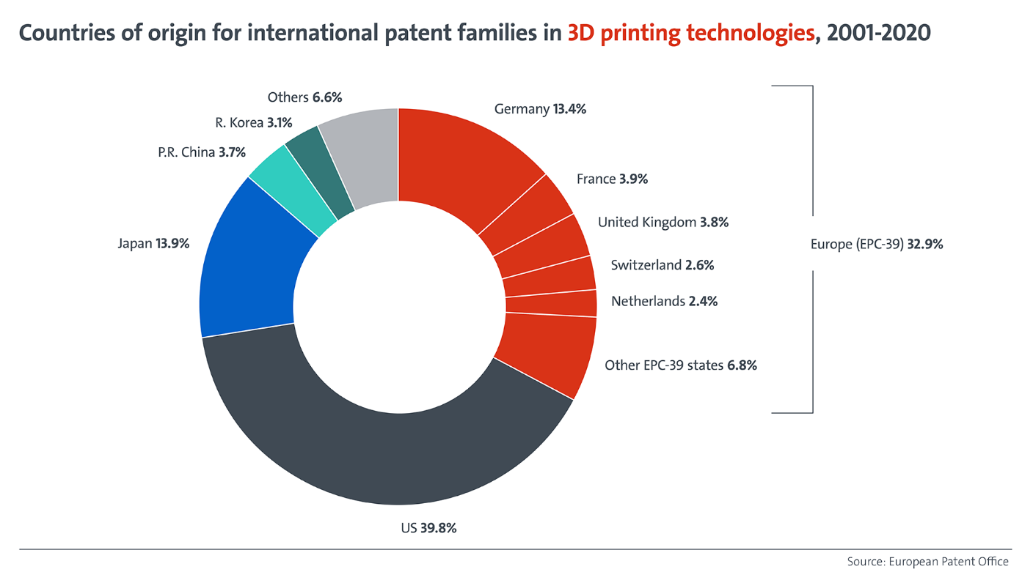
US, European, and Japanese companies all feature in the top 20 additive manufacturing patent applicants, with the leading three being General Electric, Raytheon Technologies and HP. Siemens, in fourth position, is Europe's strongest player, with almost 1 000 IPFs. Although the list of top companies is dominated by large engineering companies in a range of sectors, the additive manufacturing innovation ecosystem consists of several specialised 3D printing companies and a vibrant start-up scene as evidenced by the variety of smaller entities seen in the EPO's statistics.
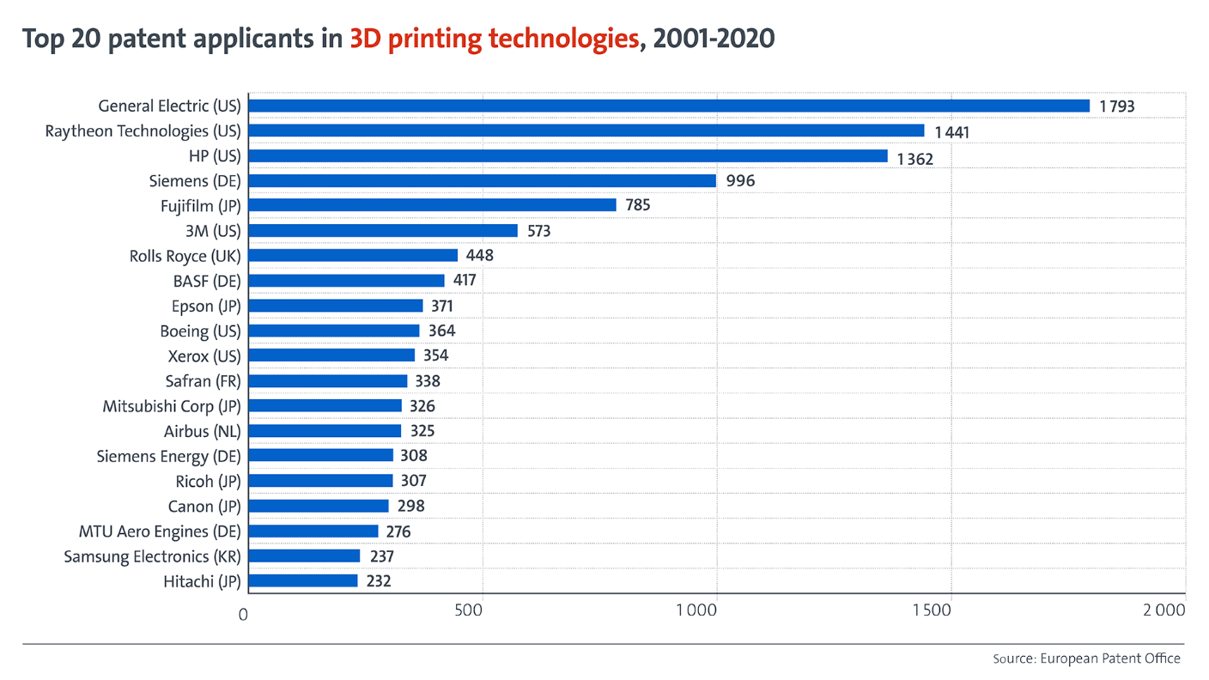
The role of research
Universities and public research organisations (PROs) also contribute significantly to 3D printing innovation. Approximately 12% of 3D printing IPFs were filed by universities or PROs, which is nearly double their typical share (7%). Every third IPF associated with biomaterial developments and every second IPF for 3D printing of organs and artificial tissue originates from a university or PRO.
Among the top ten universities, PROs or hospitals, five are located in the US. But the clear leader is Germany's Fraunhofer Gesellschaft, with 221 IPFs. The Taiwanese ITRI is the only Asian organisation to make it into the top 10, which also includes two French research institutes (CNRS and CEA) and the Dutch TNO.
Disrupting an increasing variety of industry sectors
Additive manufacturing removes traditional technical restrictions to the industrial production process, reduces waste and paves the way for mass customisation. No longer a niche technology, it is transforming manufacturing in ever more industries. Since 2010, the health, medical and transportation sectors have attracted most of the 3D printing applications. However, as 3D printing technology develops for a growing variety of materials, such as plastics, metals, ceramics, and even organic cells, rapid growth of additive manufacturing applications has also been observed in tooling, energy, fashion, electronics, construction, and even the food sector.

Roughly one-fifth of all IPFs published between 2001 and 2020 are in the health and medical sector (total of 10 000 IPFs). Additive manufacturing is particularly suited to patient-specific implants and anatomical models. The higher-than-average presence of universities, PROs and hospitals amongst patent applicants is largely explained by the advances in medical applications for 3D printing. In transport, the second-biggest sector, additive manufacturing can be used to improve product development and serial production with more than 7 000 IPFs registered in the past decade.

The EPO's research, based on patent data, offers early insights into 3D printing’s potential future uses. Because patents are filed months or even years before any products appear on the market, patent information can signal the direction technologies are taking. This report shows how vital 3D printing is to fostering innovation and sustainability across sectors around the world. It follows the publication of the EPO’s first report on patents and 3D printing in July 2020, which focused exclusively on European patents.

The additive manufacturing market has experienced strong growth, with industry revenue tripling from USD 6 billion in 2016 to USD 18 billion (EUR 16.17 billion) in 2022, according to estimates from Wohlers Associates. During the pandemic, 3D printing played a pivotal role in the switch to local production, reducing dependence on international supply chains. Projections suggest the market could exceed USD 50 billion by 2028.
Media contact
Luis Berenguer Giménez
Principal Director Communication / Spokesperson
EPO Press Desk
Tel.: +49 89 2399 1833
press@epo.org
About the EPO
With 6 300 staff, the European Patent Office (EPO) is one of the largest public service institutions in Europe. Headquartered in Munich with offices in Berlin, Brussels, The Hague and Vienna, the EPO was founded with the aim of strengthening co-operation on patents in Europe. Through the EPO's centralised patent granting procedure, inventors are able to obtain high-quality patent protection in up to 44 countries, covering a market of some 700 million people. The EPO is also the world's leading authority in patent information and patent searching.

