PRESS RELEASE

EMBARGOED UNTIL 19 March 2024 AT 00.01 CET

Innovation in digital and clean-energy technologies boosts demand for patents in Europe in 2023

- European Patent Office receives 199 275 applications in 2023, up 2.9% on previous year
- Leading countries of origin are US, Germany, Japan, P.R. China and new top five entrant Republic of Korea
- Huawei, Samsung, LG, Qualcomm and Ericsson top ranking of patent applicants
- SME power: Nearly one in four patents filed by a small company
- 27% of patent applications from Europe name at least one woman as inventor
- New Unitary Patent proves popular with patent owners: unitary effect requested for 22.3% of all European patents granted in the second half of 2023
Munich, 19 March 2024 – Companies and inventors filed 199 275 patent applications at the European Patent Office (EPO) last year, an increase of 2.9% on the previous year and the highest number to date, according to the EPO’s Patent Index 2023 published today. This follows growth of 2.6% in 2022 and 4.7% in 2021. Patent applications, which are filed to help protect and market inventions, are an early indicator of companies’ R&D investments.
“Our latest Patent Index shows that innovation remained vibrant around the world in 2023,” said EPO President António Campinos. “The EPO was entrusted with examining more applications than ever before, attesting to both the attractiveness of the European technology market and the high quality of our products and services. Europe’s small and medium-sized enterprises are making ever-increasing use of patents, with the share of applications from SMEs at its highest level yet last year. These businesses can also now benefit from the new Unitary Patent, which significantly improves the environment for innovation in Europe, providing a simpler and more cost-effective option for innovators to protect their inventions and bring them to the vast EU market.”

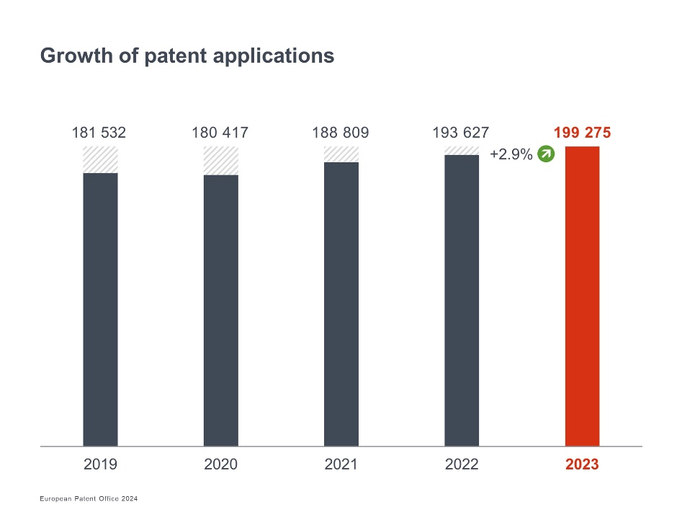

Boom in inventions in digital communication and energy technologies
The leading technical fields for patent applications at the EPO last year were digital communication (which covers technologies related to mobile networks), medical technology and computer technology. The strongest growth among all technology fields in 2023, however, was in electrical machinery, apparatus, energy (+12.2% over 2022), which covers inventions related to clean-energy technologies, including batteries (+28%). Patent activity in biotechnology (+5.9%) also continued to rise further.

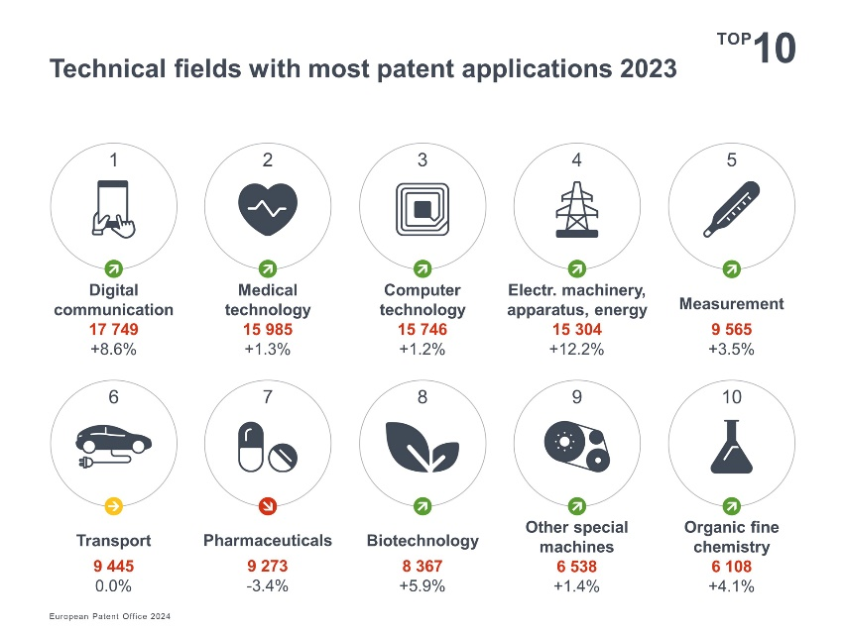

Global and European trends

The top five countries of origin for European patent applications in 2023 were the United States, Germany, Japan, China and the Republic of Korea. Some 43% of the total applications came from companies and inventors from the EPO’s 39 member states, while 57% originated from outside Europe (see chart Origin of applications).
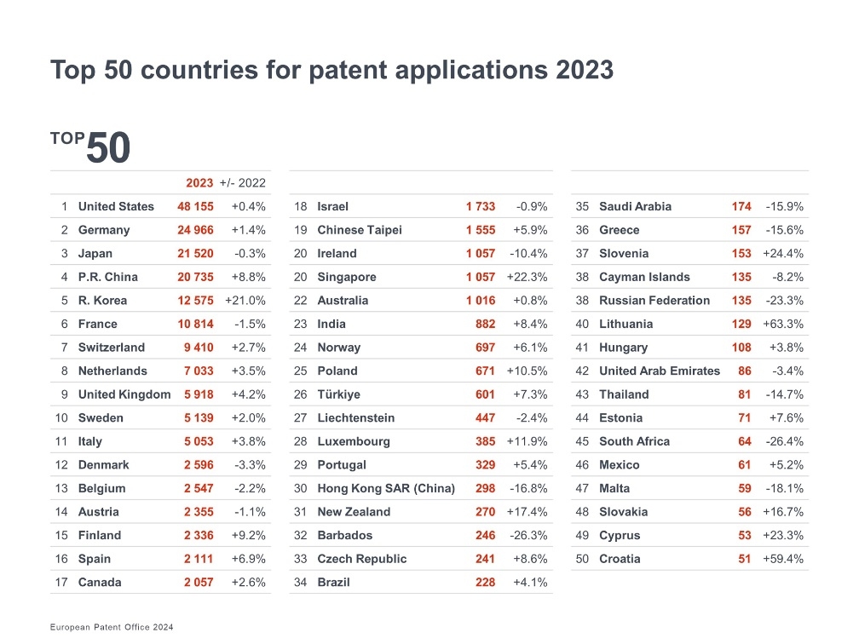

The number of patent applications originating from the EPO’s 39 member states increased again in 2023 (85 748 applications, +1.8%). European companies posted above average growth in the fields of digital communication (+10.7%), biotechnology (+6.4%), computer technology (+4.2%) and measurement (+4.0%).

Finland, Spain, UK and Italy with strongest growth in Europe

Patent applications from companies and inventors in Germany, Europe’s leading country of origin, were back to growth (+1.4%) last year compared to 2022, while French firms filed slightly fewer applications (-1.5%). Patent filings from most other European countries were up. Among the larger patent filing countries (with over 5 000 applications), the highest growth came from the UK (+4.2%), Italy (+3.8%), the Netherlands (+3.5%), Switzerland (+2.7%) and Sweden (+2.0%). Even stronger increases (among European countries with over 1 000 applications) were posted by Finland (+9.2%) and Spain (+6.9%). In terms of patent applications per capita, Switzerland again led the rankings, followed by several Nordic countries (see graph Patent applications per million inhabitants).

More inventions from China and Republic of Korea

The overall growth in patent applications at the EPO in 2023 was mainly fuelled by steep increases from the Republic of Korea (+21.0%) and the People’s Republic of China (+8.8% compared with 2022). The Republic of Korea entered the top five for the first time, while patent applications from China have more than doubled since 2018.

Other countries that showed significant growth in patent filings at the EPO last year, albeit from smaller volumes, include Canada (+2.6%), Brazil (+4.1%), Chinese Taipei (+5.9%), India (+8.4%) and Singapore (+22.3%).

Huawei tops applicant ranking

Huawei was again the leading applicant at the EPO in 2023 – increasing its applications significantly to over 5 000 and accounting for almost a quarter of all filings to the EPO from China. Samsung and LG were ranked No. 2 and 3, and together made up two-thirds of all European patent applications originating from the Republic of Korea. Qualcomm and Ericsson rounded out the top five. The top ten includes four companies from Europe, two from the Republic of Korea, two from the US and one from each of China and Japan.
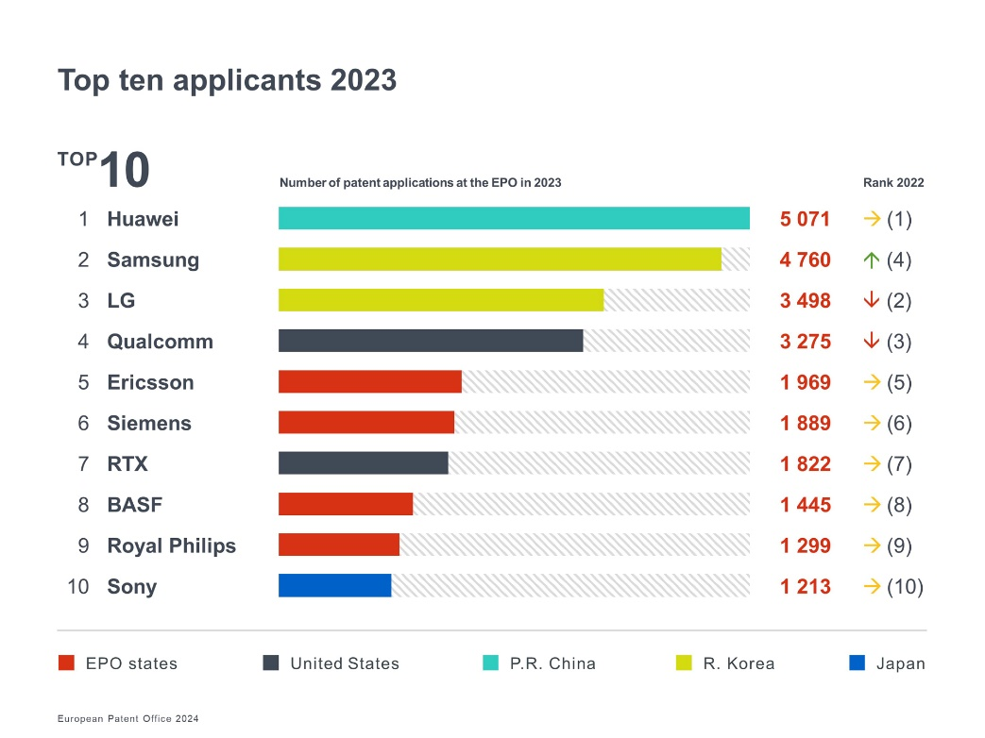

Nearly every fourth application from Europe filed by a small company

But patents are also very important for small businesses: In 2023, 23% of patent applications to the EPO originating in Europe was filed by an individual inventor or a small or medium-sized enterprise (with fewer than 250 employees). A further 8% came from universities and public research organisations (see graph Breakdown of applicants by category). As part of its ongoing support for smaller entities, the EPO has announced new fee reductions as of 1 April 2024 for micro-enterprises, individuals, non-profits, universities and public research organisations.

Spotlight on women inventors

This year’s Patent Index also looks at the contribution of women to innovation. For all patent applications filed with the EPO last year coming from Europe, 27% named at least one woman as an inventor. Among the larger European patent filing countries (with more than 2 000 applications per year), Spain (46%), France (33%) and Belgium (32%) had the highest share of patent applications naming at least one woman as inventor in 2023. In terms of technology sectors, the proportion ranged from 14% on average for patent applications in mechanical engineering to 50% in chemistry. This data can help in addressing the gaps that remain to be bridged to harness the full potential of women inventors.

Solid uptake of new Unitary Patent

Since 1 June 2023, innovators can also benefit from the Unitary Patent system – a new way to enjoy simpler and cheaper patent protection in 17 EU member states, in which a European patent has unitary legal effect and can be enforced or litigated before the new Unified Patent Court. The new system has already proven popular with patent owners: unitary protection was requested for 17.5% of all European patents granted in 2023 (more than 18 300 requests filed) and for 22.3% of those granted in the second half of 2023 after the system was launched. Patentees from Europe (39 EPO member states) had the highest uptake rate at 25.8%, followed by those from the US and China (both 10.9%), Republic of Korea (9.7%) and Japan (4.9%). The top Unitary Patent requestors in 2023 were Johnson & Johnson, Siemens, Qualcomm, Samsung and Ericsson. Of the patentees who have transformed their European patents into Unitary Patents, some two-thirds are European.

Further information
- View the Patent Index 2023 in full

- Explore and customise statistics in our Statistics & Trends Centre

- Access Unitary Patent statistics via our dedicated dashboard

- Download datasets (MS Excel) in the Download data section of our statistics page

- Check patent trends on the go with the EPO Data Hub mobile app

- Read more about the EPO’s support for SMEs, universities, non-profit organisations and other smaller applicants

Follow us on social media: X | Facebook | LinkedIn | Instagram | YouTube

Official hashtag: #EPOPatentIndex

Media contacts European Patent Office

Luis Berenguer Giménez
Principal Director Communication / EPO spokesperson

EPO press desk
press@epo.org
Tel.: +49 89 2399-1833
Mobile: +49 151 5440 3997
About the EPO
With 6 300 staff members, the European Patent Office (EPO) is one of the largest public service institutions in Europe. Headquartered in Munich with offices in Berlin, Brussels, The Hague and Vienna, the EPO was founded with the aim of strengthening co-operation on patents in Europe. Through the EPO's centralised patent granting procedure, inventors are able to obtain high-quality patent protection in up to 45 countries, covering a market of some 700 million people. The EPO is also the world's leading authority in patent information and patent searching.

