Embargo: 1 February 2024 at 00:01 CET

PRESS RELEASE
New EPO study: Inventions to fight cancer up by more than 70% since 2015

- Over 5 million lives saved in the EU thanks to advances in diagnostics and treatment
- Universities and public research institutes are emerging as drivers of innovation against cancer
- EPO launches free online tools to easily access business and technical information on cancer-related innovation

Munich, 1 February 2024– Cancer remains a global health threat despite advances in research and technology. According to the European Cancer Information System (ECIS), 31% of men and 25% of women are expected to be diagnosed with cancer in the European Union before reaching the age of 75. Over 5 million lives were saved in the EU alone thanks to inventions in oncology. Ahead of World Cancer Day (4 February), the European Patent Office (EPO) has released a new study, which finds that inventions in the fight against cancer have surged by 70% between 2015 and 2021, as measured by the number of international patent families (IPFs).

Innovation in cancer technology between 1972 and 2021
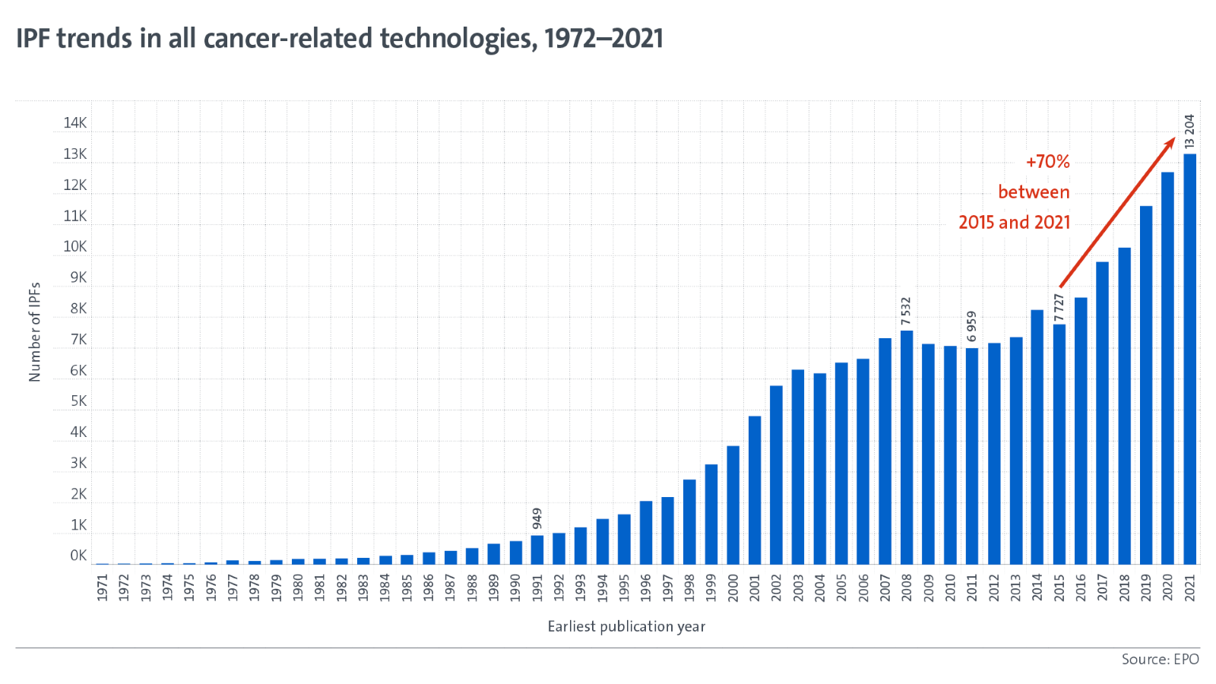

The new study, “Patents and innovation against cancer”, aims to provide decision-makers and innovators with insights into patenting of cancer technologies worldwide. It describes where and what the most recent advances have been. The report establishes that more than 140 000 inventions combatting cancer have been disclosed to the public in patent documents over the last 50 years. The study is complemented by the EPO’s free online platform, that simplifies access to innovators in the field via the technical information contained in their patents, using pre-defined patent database searches.

EPO President António Campinos said: “The platform we’re launching today can play a significant role in helping to curb cancer by empowering scientists with technical information and insight to further their research, and support them in bringing forward new technologies that can save lives. Here in Europe, we’re in second place when it comes to developing cancer-related technologies, but clearly we can do much more, we have to do more - especially when considering that there is predicted to be an increase in the number of cancer diagnoses in the coming years.”

Global fight against cancer
According to the new EPO report, the United States leads in cancer-related innovation worldwide, with nearly 50% of all IPFs from 2002 to 2021 attributed to US applicants. The European Union comes in second place with a 18% share, followed by Japan with 9%. Most recently, China has made significant strides in the field, with a large contribution to the global landscape of cancer innovation. In Europe, Germany has maintained its position as leading country of origin in cancer-related innovation, having led for over the past two decades. The UK has rapidly emerged as the second-largest contributor. France, Switzerland and the Netherlands have also demonstrated steady increases in cancer-related innovation, holding the third, fourth and fifth positions respectively.

Innovations are redefining the future of cancer treatment and diagnosis
Efforts to fight cancer have been bolstered thanks to new and improved technologies for treating and diagnosing these diseases. Breakthroughs in immunotherapies and gene therapies have played a significant role. Between 2015 and 2021, the number of IPFs in immunotherapy more than doubled, while gene therapy doubled during the same period. There has been a substantial increase in international patenting activity in the field of cancer diagnostics, especially in liquid biopsies (e.g. blood samples). IPFs in liquid biopsy grew fivefold, increasing from just over 500 in 2012 to over 2 300 in 2021. Other new advancements in healthcare informatics have focused on using advanced image processing techniques and machine learning algorithms to improve the precision and efficiency of cancer detection and diagnosis.

Increasing role of universities and public research centres
The way these innovations make their way to the market is changing. The study also points out a possible shift over the last two decades. Universities, hospitals, public research organisations and start-ups are playing an increasingly important role. They have been instrumental in almost one-third of IPFs related to cancer between 2002-2021, accounting for 26% of all IPFs from EU applicants and 35% of IPFs from US applicants, significantly surpassing their average contribution across all technologies.

France’s INSERM and CNRS stand out as key hubs for cancer innovation, ranking third and seventh globally in the most recent five-year period, 2017-2021. Other notable contributors among the top applicants include pharmaceutical companies from the US and Europe, primarily focusing on innovative cancer treatments, while several companies, such as Philips, Siemens, and Fujifilm specialise in diagnostics.

Top 10 applicants for 2017-2021
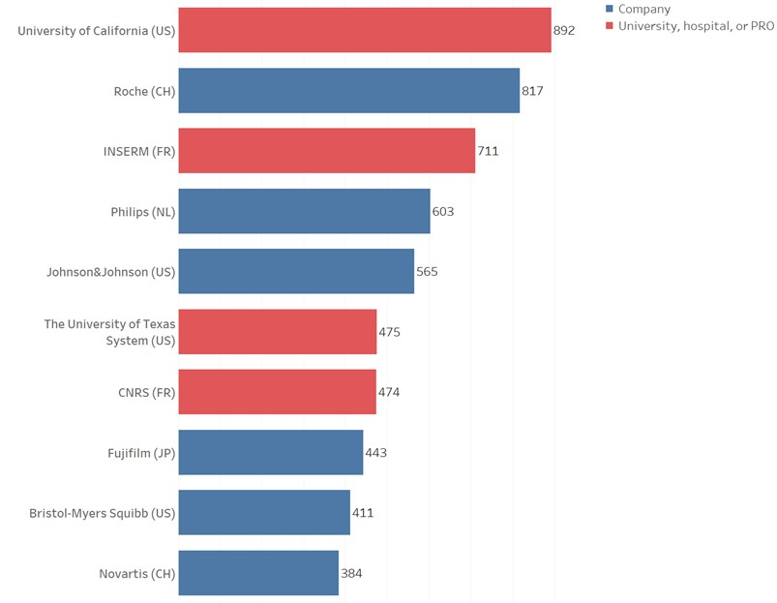

New platform to facilitate access to information and new tools to facilitate investment
The new free online platform, “Technologies combatting cancer”, has been developed by EPO experts, in collaboration with 10 national patent offices in Europe. The tool presents over 130 datasets across four broad themes: prevention and early detection; diagnosis; therapies; and well-being and aftercare. The platform includes not just the 140 000 inventions on which the study was based, but many more besides. This is the fourth such platform from the EPO, following those on coronavirus, clean energy technologies and firefighting.

To help in the development and commercialisation of new technologies combatting cancer, the EPO is updating its free tool “Deep Tech Finder”, which maps almost 8 000 start-ups from all over Europe with patent applications. The tool now includes filters for 17 different cancer-related technologies, relating to 1 340 investment-ready start-ups in this field. This helps investors and potential partners find European start-ups with valuable new cancer technologies in the deep tech sector.

Further information:
- Read the full study
- Access the EPO’s “Deep Tech Finder”
- Access the “Technologies combatting cancer” platform
- Meet some of the cancer innovators
- Join the EPO’s online event: Combatting cancer: how innovation actors are changing the landscape

About the EPO
With 6 300 staff, the European Patent Office (EPO) is one of the largest public service institutions in Europe. Headquartered in Munich with offices in Berlin, Brussels, The Hague and Vienna, the EPO was founded with the aim of strengthening co-operation on patents in Europe. Through the EPO's centralised patent granting procedure, inventors are able to obtain high-quality patent protection in up to 45 countries, covering a market of some 700 million people. The EPO is also the world's leading authority in patent information and patent searching.

Media contacts European Patent Office

Luis Berenguer Giménez
Principal Director Communication, Spokesperson

EPO Press Desk
Tel. +49 89 2399 1833
press@epo.org

Dalmartello M. et al., 2022

