
PRESS RELEASE

EMBARGOED UNTIL 24 March 2026 AT 00.01 CET

Demand for European patents exceeds 200 000 for first time, confirming Europe’s competitiveness as a global tech hub

- EPO Technology Dashboard 2025 (formerly Patent Index) reports record year for the European Patent Office
- Strong growth in digital, AI, quantum, semiconductor and battery technologies
- USA and Germany remain top countries of origin as China enters top three for first time
- Samsung, Huawei and LG lead applicant rankings, with Nokia rising to No. 5
- Unitary Patent system continues to gain momentum, particularly among Europe’s small businesses

Munich, 24 March 2026 – The European Patent Office (EPO) received a record 201 974 patent applications last year, according to the EPO Technology Dashboard 2025 (formerly Patent Index) published today. Patent filings increased by 1.4% in 2025 marking a return to steady growth. Applications from Europe, including all 39 EPO member states, rose by 0.4% (EU27: +0.7%), while those from outside Europe were up 2.1%. Patent applications are an early indicator of R&D investments.

“The record volume of patent applications underlines Europe’s innovative capacity and its appeal as a global technology market,” said EPO President António Campinos. “The Technology Dashboard 2025 tracks progress and gaps across industrial sectors, helping policymakers in Europe identify priority areas and target actions and investments to strengthen tech sovereignty and competitiveness. While the Unitary Patent is already removing barriers and accelerating the transition to a more integrated European innovation market, continued focus is needed, especially on strategic sectors such as AI, semiconductors, health and quantum technologies.”

Tech trends: digital and clean-energy innovations drive growth

Computer technology remained the leading field in 2025 (+6.1% vs 2024), boosted by an increase in patent applications for AI-related technologies (+9.5%), and in the small but fast-growing area of quantum technologies (+37.9%). While the US accounted for the largest overall share of computer technology applications, European innovators held the biggest share in both the AI and quantum sub-fields, and increased filings by +2.6% and +22.1% respectively.

Digital communication, which includes inventions for mobile networks, ranked second and recorded the strongest overall growth of the leading fields (+11.4%), fuelled in part by the global race to develop 6G technologies. The field was led by applicants from the US, China and Europe, with European innovators posting 23.5% growth.

Electrical machinery, apparatus, energy ranked third, growing by 5.3%, supported by a 14.6% increase in battery innovation. Patent filings in battery technologies were dominated by innovators from the Republic of Korea, China and Japan, both in terms of share and growth rates. Semiconductor technology also continued its upward trend (+7.6%), with European applicants holding the largest share, followed by the US.
In contrast, while medical technology was up 1.3%, some health-related sectors declined, including pharmaceuticals (-6.3%) and biotechnology (-3.3%). This highlights the importance of further strengthening Europe’s innovation framework for companies and researchers working in life sciences, including progress on the proposed Unitary Supplementary Protection Certificate and the EU Biotech Act.
Overall, European innovators led in eight of the top ten technology fields, demonstrating strength across a broad range of sectors.
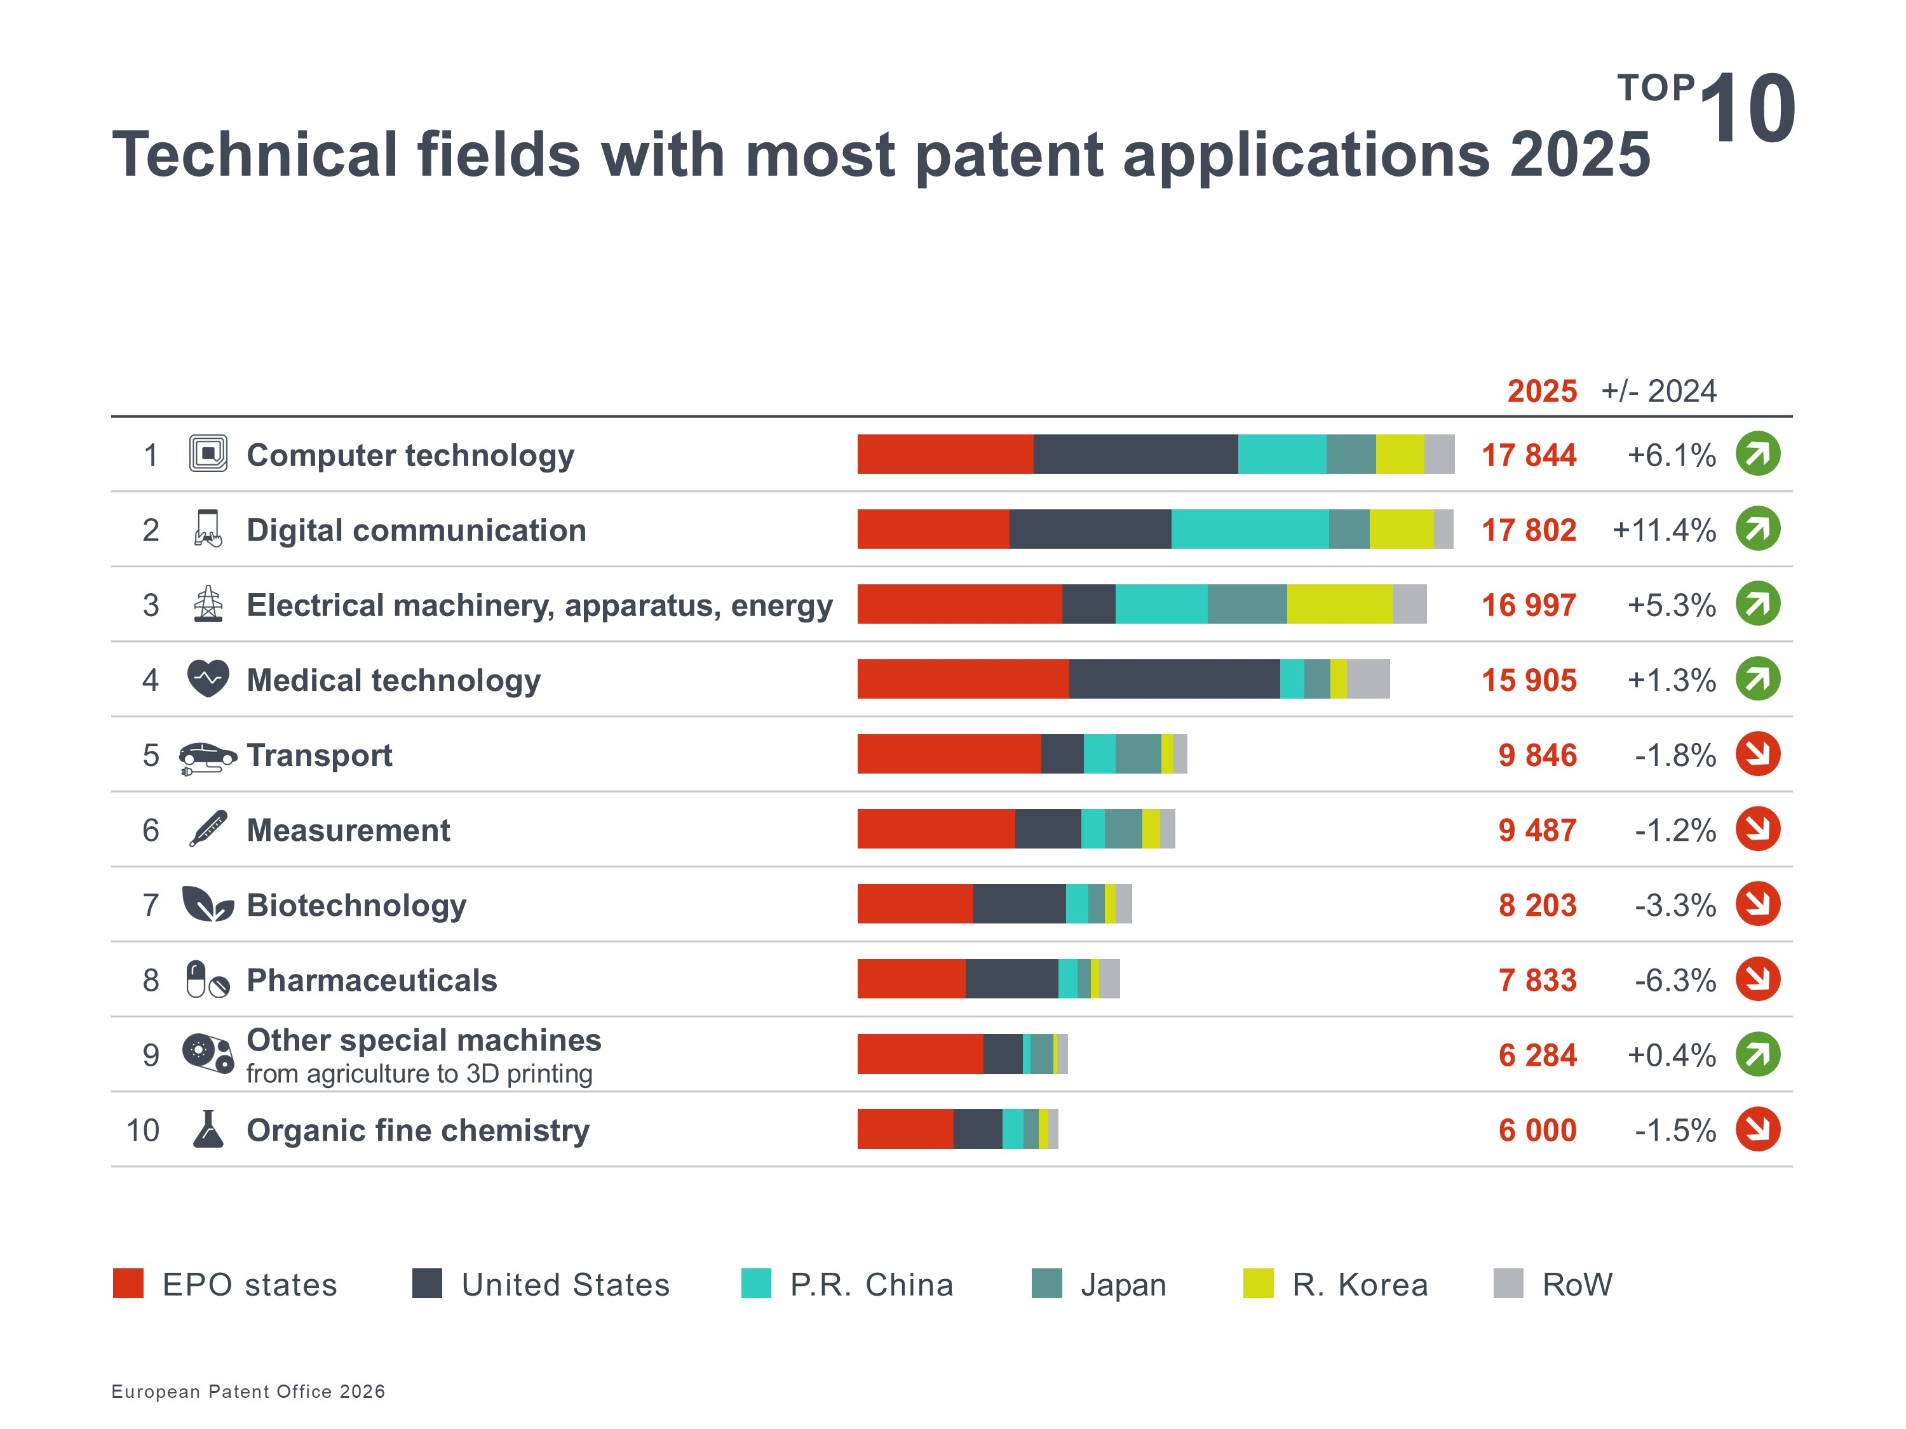

Country trends: China and R. Korea post strongest growth

The US (-1.6%) maintained its overall position as the top country of origin for European patent applications, followed by Germany (-2.2%). For the first time, China (+9.7%) overtook Japan (+1.1%), becoming the third-largest country of origin. Applications from China have tripled since 2016, while those from Republic of Korea (up +9.5% in 2025) have doubled in that time. EPO member states now account for 43% of filings, while 57% come from outside Europe (see graph Origin of applications).

Within Europe, growth was driven by mid-sized patenting countries such as Denmark (+5.2%), Austria (+5.0%), Spain (+2.9%), and especially Finland (+44%), even as filings from traditional leaders like Germany (-2.2%), France (-0.4%), Switzerland (-0.5%), Netherlands (-0.7%), the UK (-3.3%), Italy (-1.8%) and Sweden (-4.3%) were down.

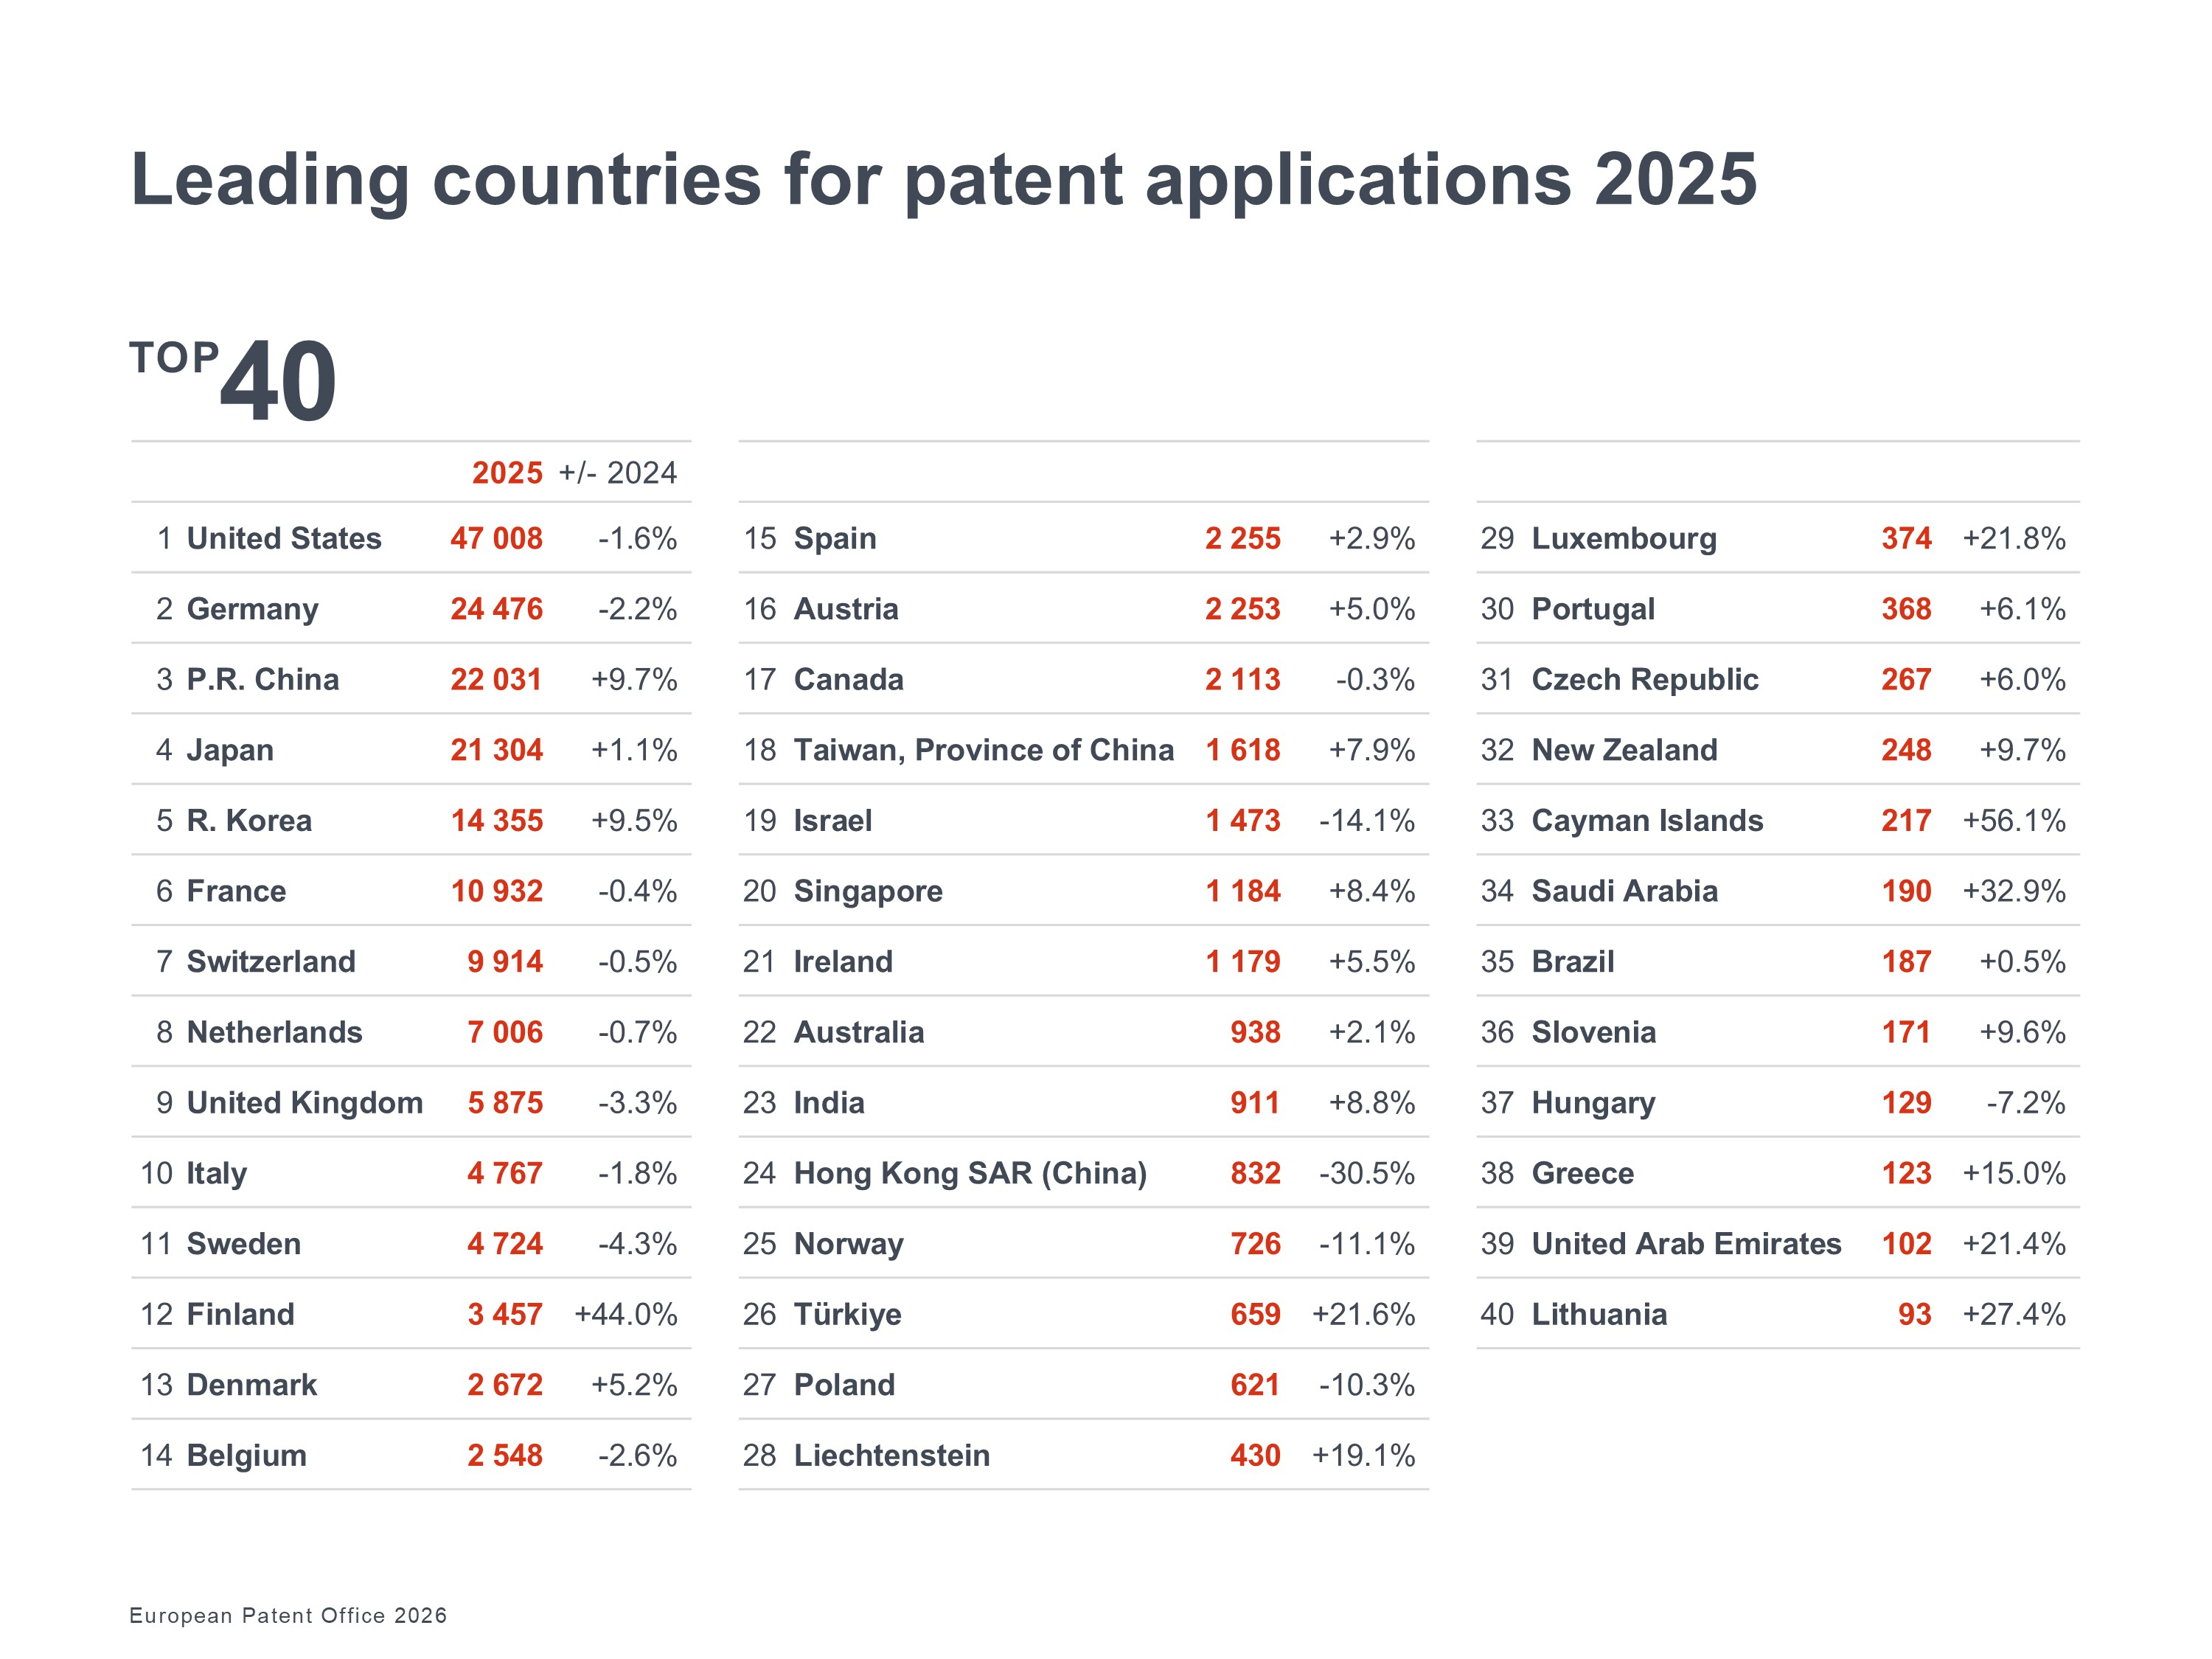

Four of the top ten applicants are from Europe
Samsung, Huawei and LG maintained their position as the top three applicants at the EPO in 2025, growing further. Four of the top ten were European companies, with Nokia climbing to 5th position in 2025 (up from 12th in 2024) and posting the fastest growth among the Top 50. Microsoft (9th) and Chinese battery manufacturer CATL (10th) also entered the top ten.

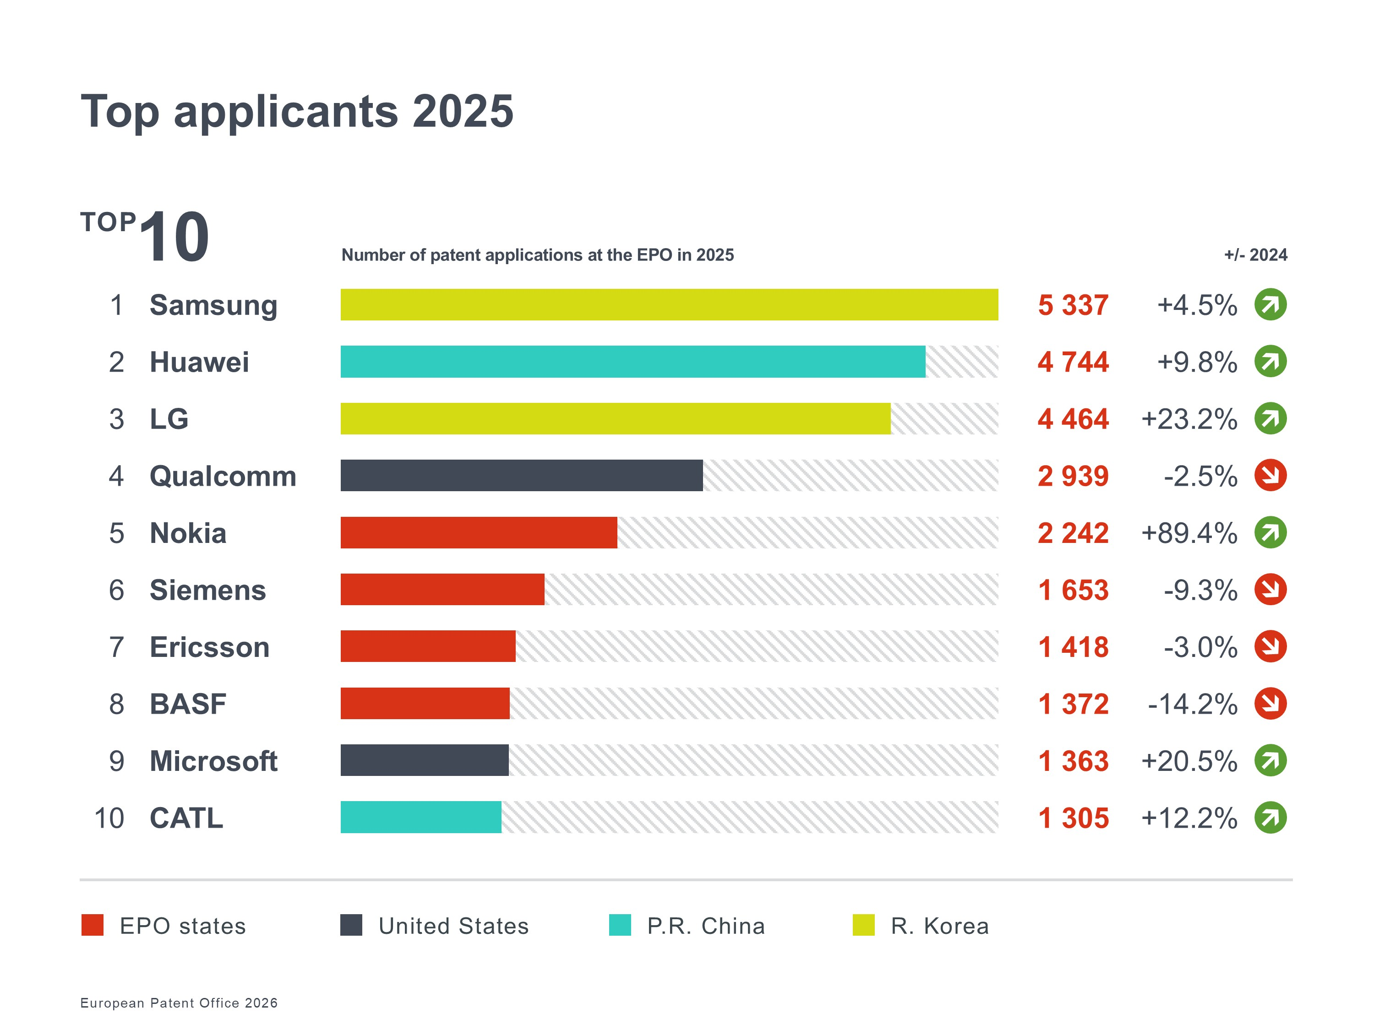

Smaller players increasingly use the Unitary Patent

In 2025, 26% of applications originating in Europe came from individual inventors or SMEs (companies with fewer than 250 employees), with an additional 7% from universities and public research organisations (see graph Breakdown of applicants by category). This highlights the patent system’s role as a springboard for smaller entities to scale their inventions, further strengthened by recent fee reductions for micro-enterprises, individuals, non-profits, universities, and research institutions.

The Unitary Patent, launched in 2023, has rapidly become a cornerstone of this ecosystem. With over 80 000 requests to date and an uptake rate of 28.7% in 2025, it offers a simplified path to protection across 18 EU states. Patentees from the EPO member states had the highest uptake last year, with 40.0% of their European patents transformed into Unitary Patents, followed by those from China (22.6%), the US (19.7%), Republic of Korea (19.1%) and Japan (9.8%). While global players such as Samsung, Siemens, Johnson & Johnson are the biggest requestors, SMEs, universities, and public research organisations now account for nearly half of all Unitary Patents granted to European innovators. This confirms the Unitary Patent is meeting its objective of providing smaller players with a cost-effective route to a market of 350 million people.

Further information
- EPO Technology Dashboard 2025
- Statistics & Trends Centre
- Unitary Patent statistics
- Statistics page to download complete datasets (Excel)
- EPO Data Hub mobile app
- Observatory on Patents and Technology
- Resources for startups and SMEs

Follow us on social media: X | Facebook | LinkedIn | Instagram | YouTube

Official hashtag: #EPOTechDashboard

Media contacts European Patent Office

Roberta Romano-Götsch
EPO spokesperson
EPO press desk
press@epo.org
Mobile: +49 151 5440 3997
About the EPO
With 6 300 staff members, the European Patent Office (EPO) is one of the largest public service institutions in Europe. Headquartered in Munich with offices in Berlin, Brussels, The Hague and Vienna, the EPO was founded with the aim of strengthening co-operation on patents in Europe. Through the EPO's centralised patent granting procedure, inventors are able to obtain high-quality patent protection in up to 46 countries, covering a market of over 700 million people. The EPO is also the world's leading authority in patent information and patent searching.

About the EPO Technology Dashboard
The EPO Technology Dashboard (the new name for the former annual Patent Index) is a tool for tracking global innovation trends, offering insights into European patent application activity across industries and regions. By analysing patent data, the dashboard serves as a barometer for technological progress, R&D investment, and competitiveness – helping businesses, policymakers, and researchers understand the changing dynamics of the current innovation landscape.

