

**PRESS RELEASE**

**EPO site in Zuid Holland significant contributor to local economy**

* **Total value added in 2023: EUR 840 million**
* **EPO’s presence generates further jobs**

**Rijswijk, 22 May 2025 -** A recent study commissioned by the European Patent Office (EPO) and conducted in 2024 quantified the direct and indirect impact on the local economy of the organisation’s site in The Hague region. The total value added in 2023 was EUR 840 million.

In 2023, the EPO employed approximately 2 500 staff in the Netherlands. Their spending and the EPO’s purchase of goods and services from local companies resulted in an added value of about EUR 780 million. The organisation’s presence created an additional 3 700 jobs in the country, meaning that, statistically, for every EPO staff member 1.5 external jobs were generated. Compared to 2018, these figures represent a 5% increase.

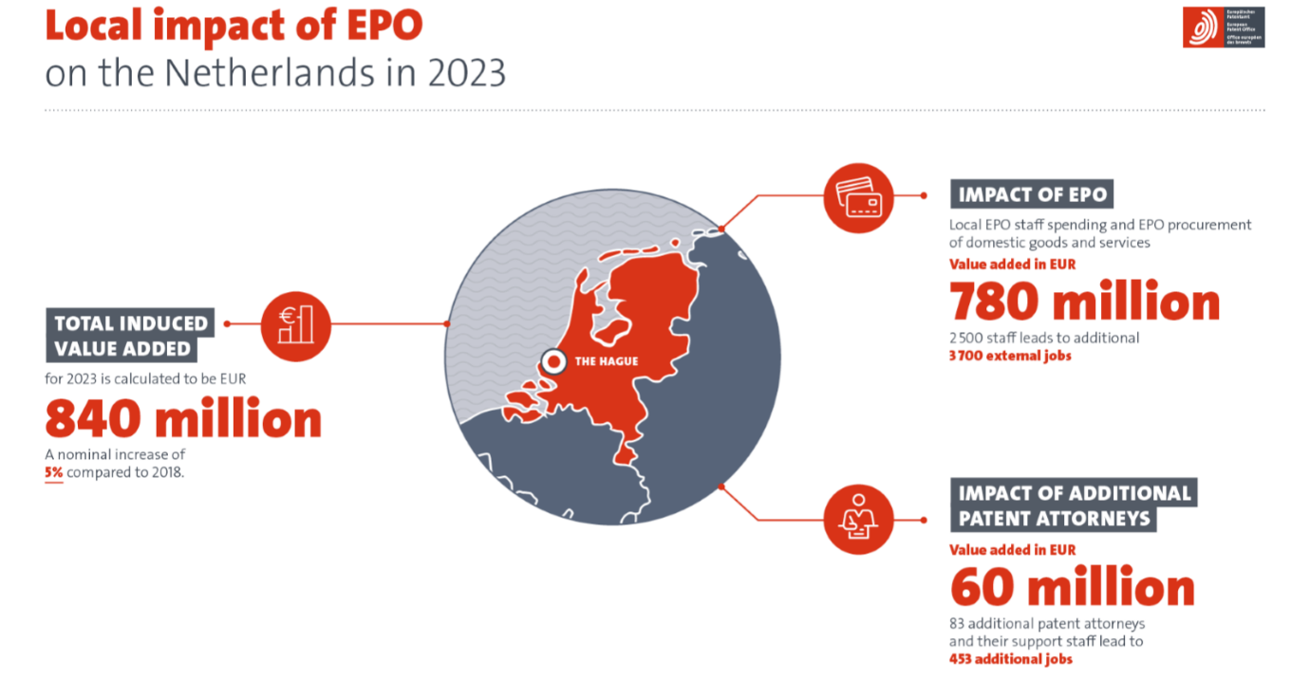

In the same year, over 80 European patent attorneys and 160 support staff contributed around EUR 60 million in value added and generated over 200 more jobs in the local economy. In total, the EPO's presence in the Netherlands led to around 450 more external jobs.

*“We are happy to be part of a vibrant innovation ecosystem that thrives on collaboration and creativity and delivers quality and service. Our presence is rooted in a shared commitment to progress. We are proud to grow alongside this region and contribute to its continued success,”* said EPO President António Campinos. *"In line with the EPO's mission to contribute to a safer, smarter and more sustainable world, we endeavour to support the region beyond adding economic value by celebrating diversity and promoting sustainability”.*

**Media contacts European Patent Office**

**Luis Berenguer Giménez**   
Principal Director Communication / EPO spokesperson

**EPO press desk**

[press@epo.org](mailto:press@epo.org)   
Tel.: +49 89 2399-1833

Mobile: +49 151 5440 3997

**About the EPO**

With 6 300 staff members, the [European Patent Office (EPO)](http://www.epo.org/) is one of the largest public service institutions in Europe. Headquartered in Munich with offices in Berlin, Brussels, The Hague and Vienna, the EPO was founded with the aim of strengthening co-operation on patents in Europe. Through the EPO's centralised patent granting procedure, inventors are able to obtain high-quality patent protection in up to 45 countries, covering a market of some 700 million people. The EPO is also the world's leading authority in patent information and patent searching.